Internship Project Report: Network Scanner

Project Title: Network Scanner Using Python and Scapy.
Name of intern:Sahasra Chandhana Reddigari
Intern Number: ITID5926
Internship Duration: [15/11/2025 to 15/02/2026 ]
Internship Organization: [ InLighnX Global Pvt. Ltd.]

1.Project Objective:
The objective of this project is to develop a Python program that scans the local network to detect all connected devices. The program identifies the IP and MAC addresses of devices connected to the user’s Wi-Fi network.
Note: This project scans only the user’s own local network and does not access or interfere with external or unauthorized systems.

2. Tools and Technologies Used:
- Python 3.13 – Programming language
- Scapy – Python library for sending/receiving network packets
- Windows 10 – Operating system
- Npcap – Packet capture driver for Windows (required by Scapy)
- PowerShell – For running the Python script

3. Installation Steps:
1. Install Python 3.13 from python.org.
- Select “Add Python to PATH” during installation.
2. Install Scapy using pip:
pip install scapy
3.Install Npcap (from https://npcap.com) to allow packet capturing.
4. Open PowerShell as Administrator to run the network scanner.

4. Project Implementation:
The project uses the ARP protocol to detect devices in the local network. The steps are:
1.Send ARP requests to all IPs in the user’s subnet.
2. Receive responses from active devices.
3. Extract and display the IP and MAC addresses.

Python Code Snippet:
from scapy.all import ARP, Ether, srp

def scan_network(ip_range):
"""
Scans the given IP range and returns a list
of connected devices with their IP and MAC address.
"""
arp_request = ARP(pdst=ip_range)
broadcast = Ether(dst="ff:ff:ff:ff:ff:ff")
packet = broadcast / arp_request

result = srp(packet, timeout=2, verbose=False)[0]

devices = []
for _, received in result:
devices.append({
"ip": received.psrc,
"mac": received.hwsrc
})

return devices

def main():
print("\nStarting network scan...\n")

ip_range = "192.168.1.1/24" # Adjust if router uses different range
devices = scan_network(ip_range)

print("Devices currently connected to the network:")
print("-" * 50)

if devices:
for device in devices:
print(f"IP Address: {device['ip']:<15} | MAC Address: {device['mac']}")
else:
print("No active devices found.")

if __name__ == "__main__":
main()
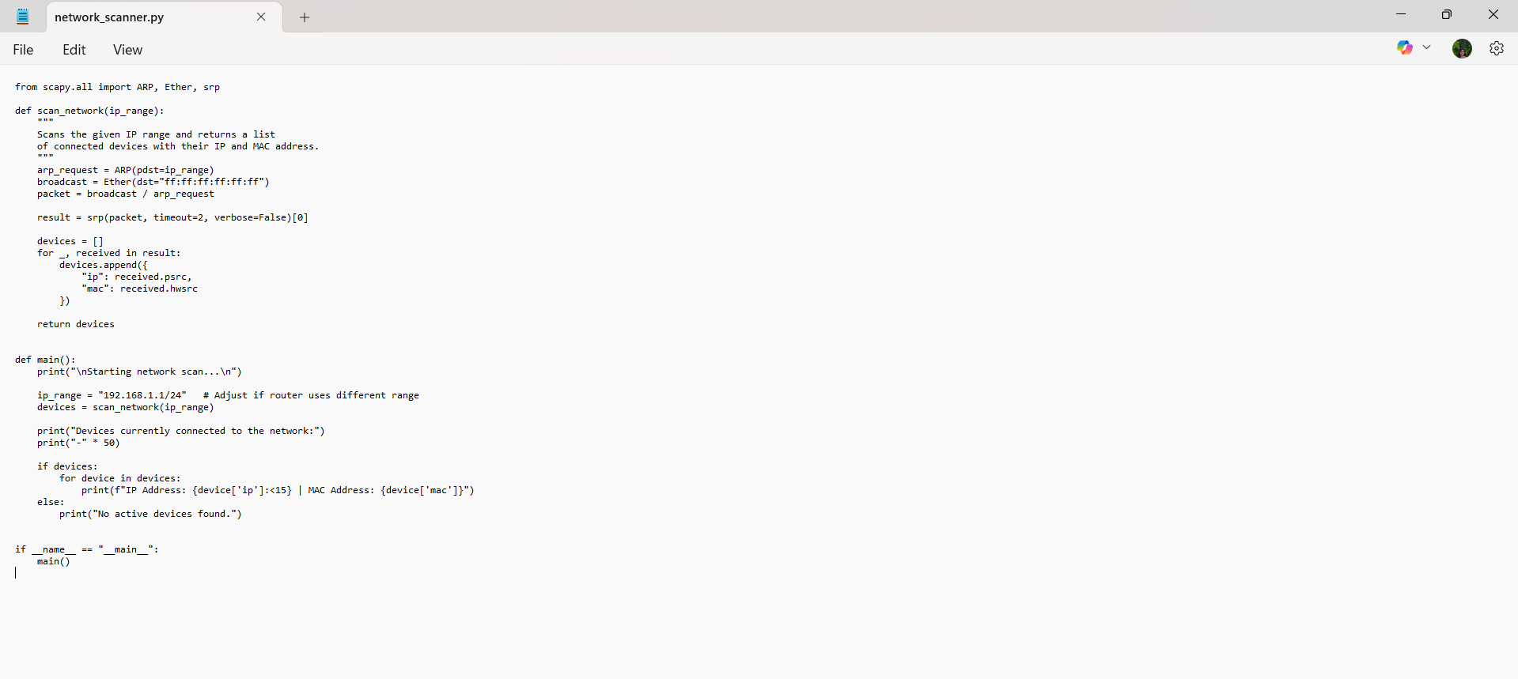
5. Running the Project:
1.Open PowerShell in the folder where the script is saved:
cd Documents
python network_scanner.py
2. Output will display the devices connected to the network, for example:
Starting network scan...

Devices currently connected to the network:
--------------------------------------------------
IP Address: 192.168.1.8 | MAC Address: 78:af:08:7f:61:f1

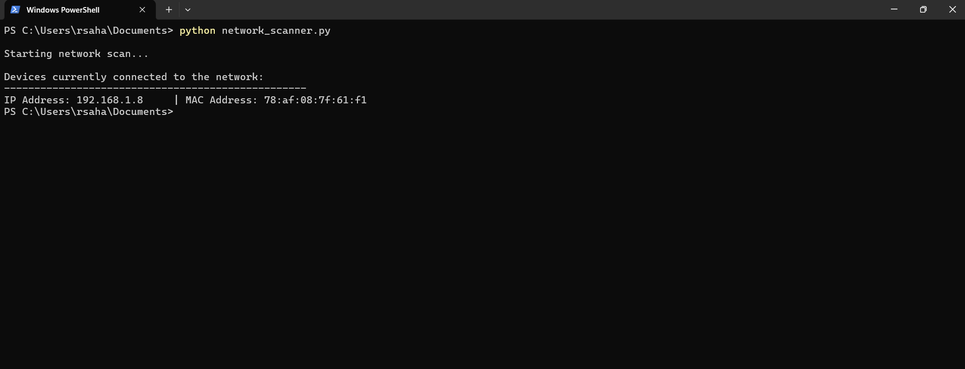

6. Observations and Results:
- The scanner successfully detects devices on the local network.
- Only devices connected to the same Wi-Fi network are displayed.
- The project demonstrates practical use of Python networking and packet analysis.

7. Conclusion:
This project demonstrates how to use Python and Scapy to monitor and analyze a local network. It reinforces concepts such as ARP requests, MAC/IP address mapping, and packet sniffing.

Ethical Consideration: The project is ethical and safe as it scans only the user’s own network.

